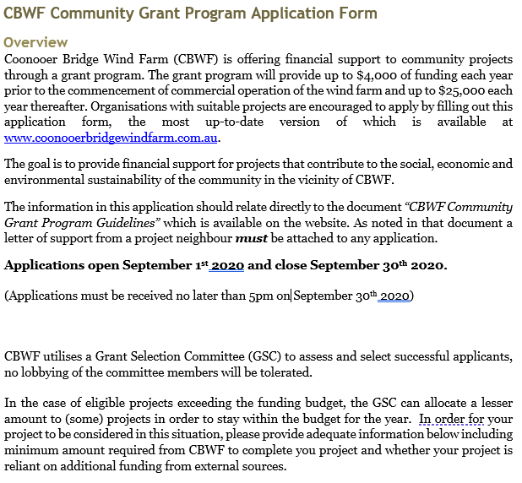

Grant Application Summary
Required information |  | Applicant provided response
Project name
Project location
Name of organisation applying for a grant
Brief description of the organisation applying for a grant
ABN of the organisation applying for a grant
Is your organisation registered for GST ?
Address of the organisation applying for a grant
Details of organisation representative | Name:
 | Position:
 | Phone:
 | Email:
Brief project summary (max 100 words)
What is the total cost of the project
Maximum funding amount applied for from CBWF
Is the organisation willing to accept a reduced funding amount?
If so, what is the minimum amount required to complete the project
Is the project reliant on additional external funding to reach completion?
If so, please provide additional details
Expected date of project completion

Project Details
Include in this section information about the project and how it will help to contribute to achieving the goals of the grant program. Reference to the “CBWF Community Grant Program Guidelines” is important. Make sure to also include information on the following details:
- A summary of what the project is, including where it is
- An indication of the objectives of the project, what the planned outcomes are and how they can be measured
- An explanation of how the community will benefit
- An estimation of how many people will benefit
- What contribution/in kind support your organisation will make towards the project
- Who will manage the project
- What the overall cost of the project is
- What the timeline of the project is
- Any additional information deemed relevant
(please attach additional pages if required)

Additional Information
Required information | Applicant provided response
How did you hear about the community grant program?
Are there any disclosures regarding the project or your organisation you wish to make?
Is your organisation willing to allow the project to be used for promotional purposes by CBWF?

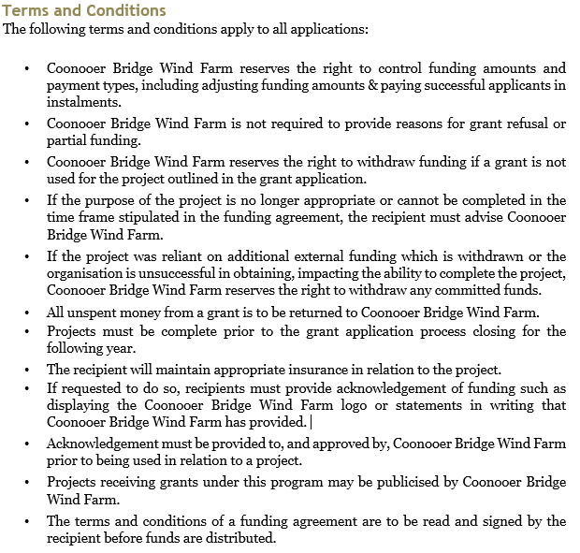

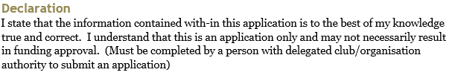
Full Name
Position
Signature |  | Date

